How did different people shape the American Revolution?

Background
By the time of the American Revolutionary War, the backbone of New England’s economy was trade with the West Indies (also known as the Caribbean). In 1764, the British government passed the “Sugar Act,” a new law specifically targeting this trade. It required colonists pay taxes when trading with French, Dutch, and other “foreign” colonies in the West Indies. Colonists caught breaking the law had to pay heavy fines and could lose large sums of money.
The Customs Service was an agency of the British government and responsible for enforcing the law. Customs Service agents collected taxes and reported colonists who broke the law.
Some New Englanders believed the British government represented them. Some did not. They were furious at the government for interfering in their wealthy trade “business” and cutting into profits. They protested the law, argued “no taxation without representation,” and called for liberty from an oppressive government.
A common form of protest was “tar and feathering.” These protests could be violent attacks where people were burned with hot, liquid tar and sometimes beaten or otherwise injured.
Other British laws made it legal for white colonists to enslave African people or people of African descent. The main purpose of slavery was to make money. Although a person can never be owned, colonists considered enslaved people to be their valuable property. They profited by forcing enslaved people to work without pay.
Enslaved people listened closely to white colonists discuss their rights for equality, freedom, and independence. And they understood how these revolutionary ideas applied to their own lives. They also found ways to challenge the power of their enslavers and break down an oppressive system of government. One of the most powerful acts of protest was to self-emancipate, essentially free oneself from slavery.
The ideas of freedom and equality enshrined in the Declaration of Independence were not meant to extend beyond land-owning, white men. But nevertheless, enslaved Africans refused bondage and demanded freedom from slavery. By emancipating themselves, they made the ideals of freedom and equality true for Black women and men.

Document A

Thomas Row Affidavit

(Transcription modified for length and clarity.)

Thomas Row worked for the British Customs Service in Salem, Massachusetts. In 1768, he reported a group of colonists secretly removing molasses from a ship to avoid paying taxes. They were in direct violation of the Sugar Act. The next day Thomas Row was violently attacked by a group of Salem men. This is an excerpt from a statement by Row describing his assault.
A separate primary source document (not included here) describes several Salem colonists joining the mob. Although they were not the shipowner in question, they were impacted and angered by the Sugar Act. This included Richard Derby, a wealthy Salem merchant who was heavily involved in the West Indies trade.

I, Thomas Row declare… a number of sailors forcibly dragged me to the Common, waxed the hair of my and cut part of it off from behind. Then they carried me to the Tree of Liberty, stripped off my coat, waistcoat, handkerchief & hat and tied my hands to a long pole & tarred me all over. Then I was stuck with feathers over my face, head, shirt, and trousers.
In this miserable condition I was dragged along by the mob from the Common into the main street where they put a cross made with sticks into my hand, struck me several violent blows on my head, and swore they would murder me if I did not carry it upright.
In this shameful manner I was conducted through the streets, a live goose repeatedly thrown at me.
Then I was carried out of the town and set at liberty. George Crowninshield, pushing me by the neck, said that if I returned to that town again, I should lose my life.
Thomas Row
September 9, 1768.

Vocabulary
- Merchant: colonists who supplied trade goods to local and overseas customers.
- Tree of Liberty: leading up to the American Revolutionary War, colonists chose trees and erected poles to be symbols of revolutionary ideals and a place to gathered and protest.

Document A
(Page 3 of 3)

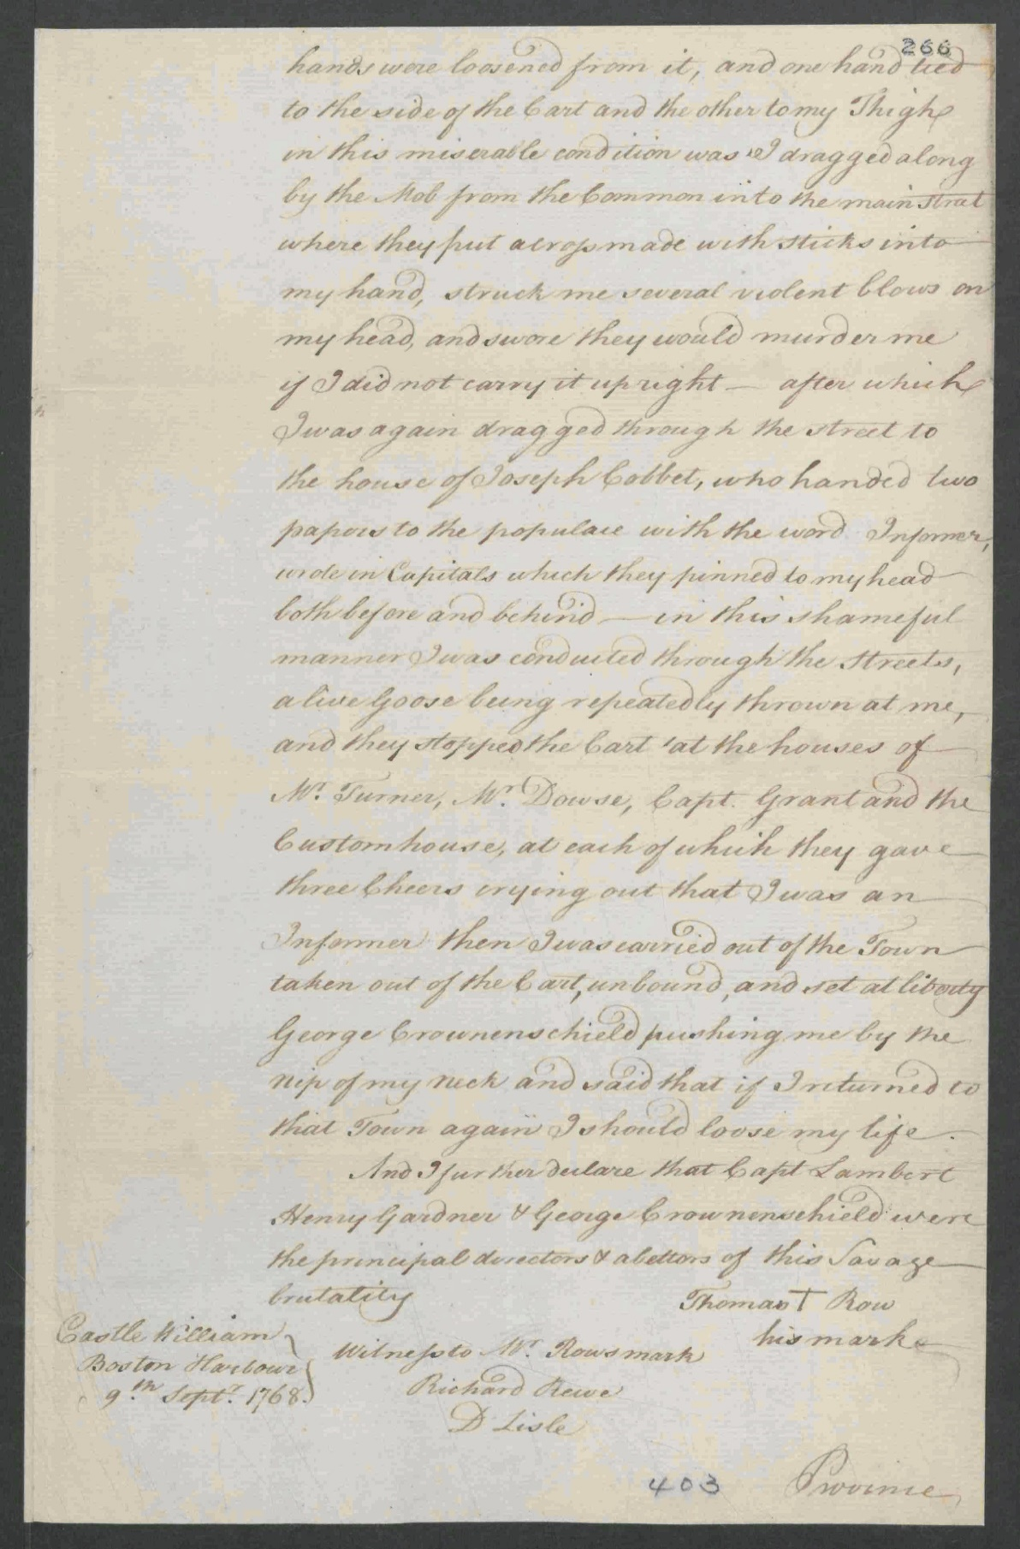
Image Source
The National Archives, United Kingdom. Copy of Thomas Row(e)'s Affidavit concerning the insult he received from the Mob at Salem. Dated Castle William, Boston Harbor, September 9, 1768. T 1/465/265-266.

Document B

Obed’s Broadside Advertisement

(Transcription modified for length and clarity.)

Richard Derby was a wealthy, Salem merchant. From primary source documents, we know he enslaved at least six people in his lifetime. He posted this broadside (announcement) in public places and in a Salem newspaper in 1774.

Advertisement
Ran-away from the Subscriber last Saturday, a Negro man named Obed, about 25 years of age, somewhat tall, his skin very black his nose uncommonly long for a Negro. He was born at Cohasset, in this Province; it is uncertain what clothes he had on as he carried away a considerable quantity with him, among which were a red coat with brass buttons, green jacket and breeches with white buttons. Whoever will take up and secure him, or return him to his Master, shall have three dollars reward, and all necessary charges paid by

Richard Derby
Salem, February 28, 1774.

Document B
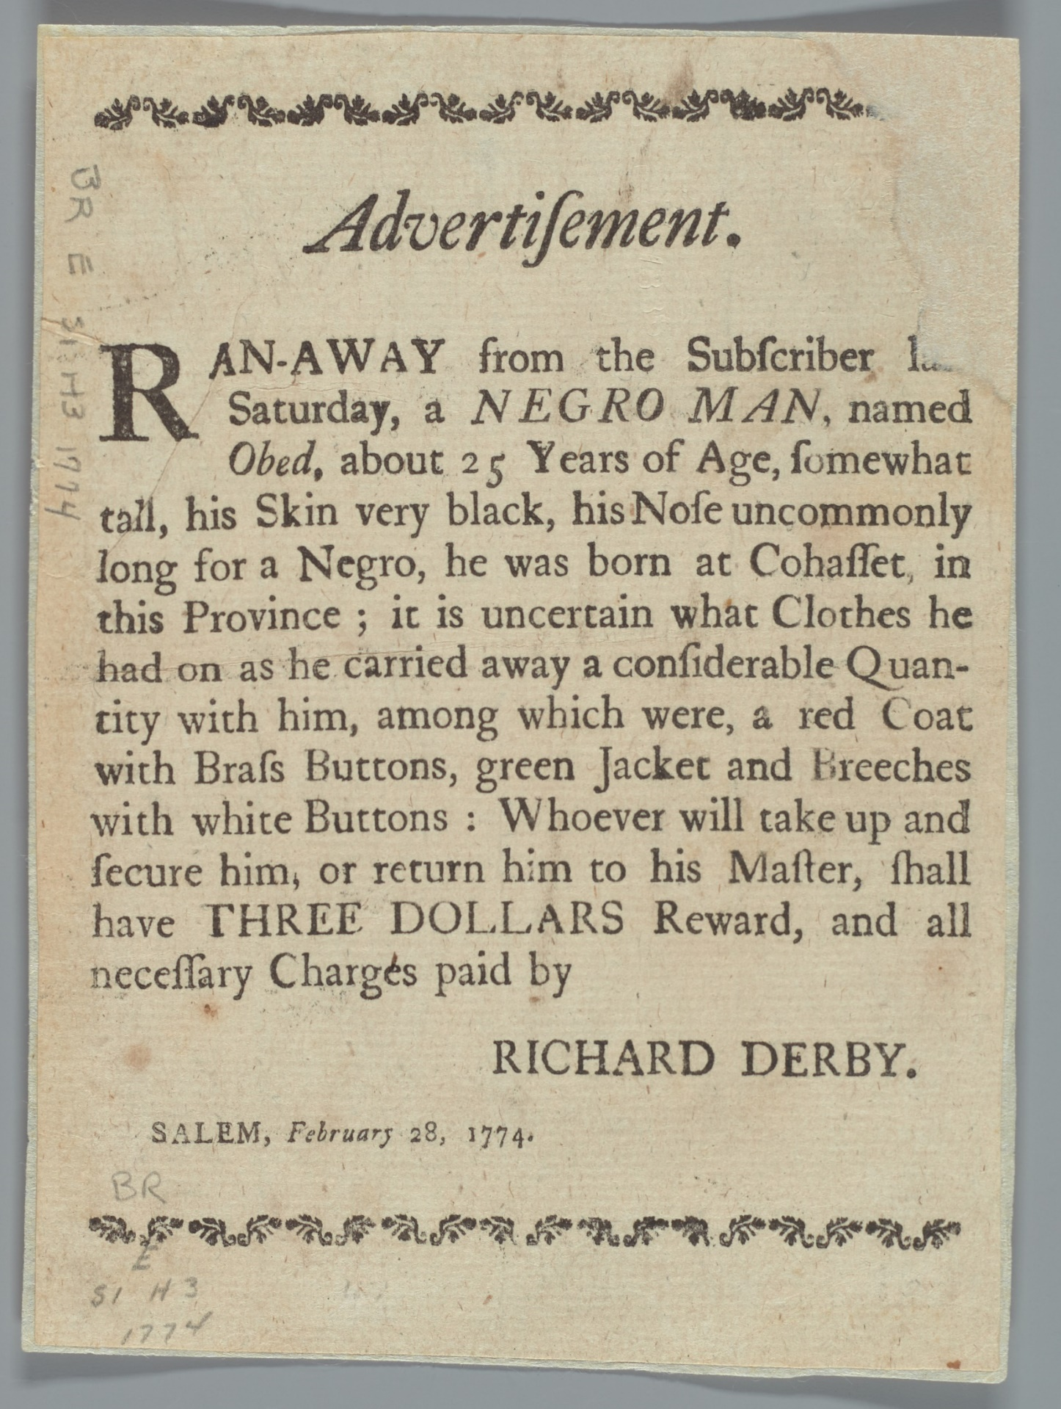
Image Source
Advertisement, 1774, Phillips Library Digital Collections (https://pem.quartexcollections.com).

Graphic Organizer

 | Document A: Thomas Row Affidavit | Document B: Obed’s Broadside Advertisement
#1
When and where was this document written?

#2
Who is the author?

(Include names, who they are/what their role is.)

#3
What was happening at this time and place that may help explain what is written?

(Use Background information.)

#4  How was each person/group’s freedom threatened? | Richard Derby (Salem colonists):  Thomas Row: | Richard Derby:  Obed:

 | Document A: Thomas Row Affidavit | Document B: Obed’s Broadside Advertisement
#5  Each person had the power to do something.  What did they do?  Who gave them that power? | Richard Derby:  Thomas Row: | Richard Derby:  Obed:
#6
How is this evidence of a revolution?

Vocabulary
Revolution: overthrow of a government, laws, or social order in favor of a new system.

